The HR department wants you to create SQL statements to insert, update, and delete employee data. As a prototype, you use the MY_EMPLOYEE table, prior to giving the statements to the HR department.
Insert data into the MY_EMPLOYEE table.
2. Describe the structure of the MY_EMPLOYEE table to identify the column names.
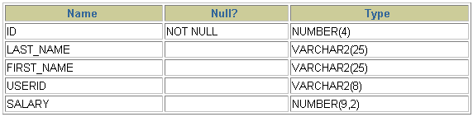
3. Create an INSERT statement to add the first row of data to the MY_EMPLOYEE table from the following sample data. Do not list the columns in the INSERT clause. Do not enter all rows yet.
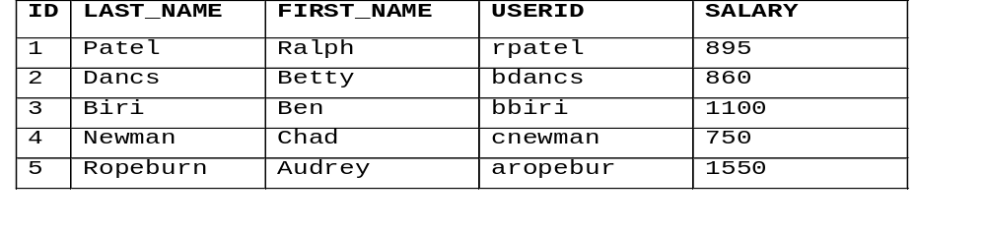

4. Populate the MY_EMPLOYEE table with the second row of sample data from the preceding list. This time, list the columns explicitly in the INSERT clause.
5. Confirm your addition to the table.
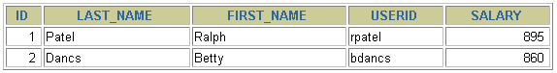
6.. Make the data additions permanent.
Update and delete data in the MY_EMPLOYEE table.
7. Change the last name of employee 3 to Drexler.
8. Change the salary to $1,000 for all employees who have a salary less than $900.
9. Verify your changes to the table.
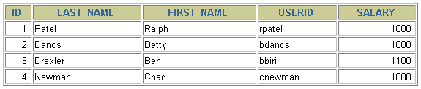
10. Delete Betty Dancs from the MY_EMPLOYEE table.
11. Confirm your changes to the table.
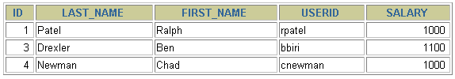
12. Commit all pending changes.
Control data transaction to the MY_EMPLOYEE table.
17. Confirm your addition to the table.
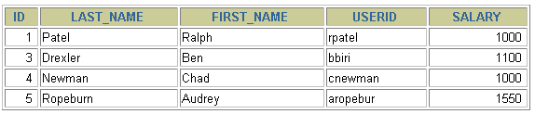
18. Mark an intermediate point in the processing of the transaction.
19. Empty the entire table.
20. Confirm that the table is empty.
21. Discard the most recent DELETE operation without discarding the earlier INSERT operation.
22. Confirm that the new row is still intact.
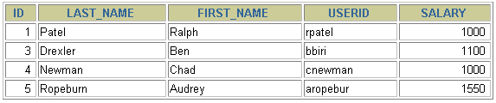
23. Make the data addition permanent.

